Name: Ravin Godbole
PRN: B25CE1087
Div: CE 2, Batch A
-------------------------------------------------------------------
Experiment name: Basic File Operations
Topic: Basic File Operations

Basic File Operations

Aim: -

The aim of this experiment is to showcase the use of basic file operations such as fprintf(), fscanf() etc.

Research: -

File handling in C is the process of creating, opening, reading, writing, and closing files to store and retrieve data permanently on a disk.
Operations are performed using functions from the standard input/output library (stdio.h) and a special FILE pointer to manage the file stream.
The history of file handling in C is deeply intertwined with the development of the Unix operating system in the early 1970s at Bell Labs.
Origins and Development:
Early 1970s (Bell Labs): The C programming language was developed by Dennis Ritchie to write the Unix operating system.
Concurrent Development: C and Unix were created concurrently, and this relationship heavily influenced C's file handling. The file I/O model implemented was the Unix stream model, which abstracts all file operations into operations on a stream of bytes.
Standard Library Functions: Unlike some earlier languages that had built-in syntax for file operations, all C file handling is done through function calls, which became part of the standard C library, <stdio.h>.

Analysis: -

Key Concepts and Functions:
The C language's file handling uses a low-level, but powerful, approach based on file pointers and streams.
File Pointers: A special pointer of type FILE * is used to manage the connection between a program and a physical file on the storage device. This pointer tracks the current position for reading or writing operations.
Streams: C treats files as a sequence of bytes (a stream), which can be text or binary.
Core Functions:
The core functions in <stdio.h> that form the basis of file handling in C are:
fopen(): Opens a file and returns a FILE * pointer.
fclose(): Closes an opened file to ensure data is saved and system resources are released.
fprintf(): Used for formatted input to text files.
fscanf(): Used for formatted output from text files.
fgetc() / fputc(): Used to read or write a single character.
fgets() / fputs(): Used to read or write strings (lines).
fread(): Used for reading blocks of data in binary mode.
fwrite(): Used for writing blocks of data in binary mode.

Ideate: -

In this program, we give the user a choice about whether they want to print data into the text file, or they want to read data from the file or display it.
In the program, we initially display a menu consisting of choices for file operations that the user can perform.
Then after the user inputs their choice, it is stored in a variable which is then used in the switchcase control statement.
In switchcase control statement, we have multiple cases as per the choice of the user.
Using those cases the file operation is implemented.

Build: -

#include<stdio.h>

int main()
{
FILE *fp;
int choice;
char filename[] = "data.txt";
char text[200];
char ch;

while(1)
{
printf("\n===== MENU =====");
printf("\n1. Write to data.txt (fprintf)");
printf("\n2. Read from data.txt (fscanf)");
printf("\n3. Display data.txt (fgetc - char by char)");
printf("\n4. Exit");
printf("\nEnter your choice: ");
scanf("%d", &choice);

switch (choice)
{
case 1:
fp = fopen(filename, "w");
if(fp == NULL)
{
printf("Error opening file!\n");
break;
}

printf("Enter text to write: ");
getchar();
fgets(text, 200, stdin);
fprintf(fp, "%s", text);

fclose(fp);
printf("Data written to data.txt\n");
break;

case 2:
fp = fopen(filename, "r");
if(fp == NULL)
{
printf("data.txt not found!\n");
break;
}

printf("\n--- Reading using fscanf ---\n");
while(fscanf(fp, "%199[^\n]\n", text) != EOF)
{
printf("%s\n", text);
}

fclose(fp);
break;

case 3:
fp = fopen(filename, "r");
if(fp == NULL)
{
printf("data.txt not found!\n");
break;
}
printf("\n--- Displaying character by character ---\n");

while((ch = fgetc(fp)) != EOF)
{
putchar(ch);
}

fclose(fp);
break;

case 4:
printf("Exiting...\n");
return 0;
default:
printf("Invalid choice!\n");
}
}
return 0;
}
Test: -

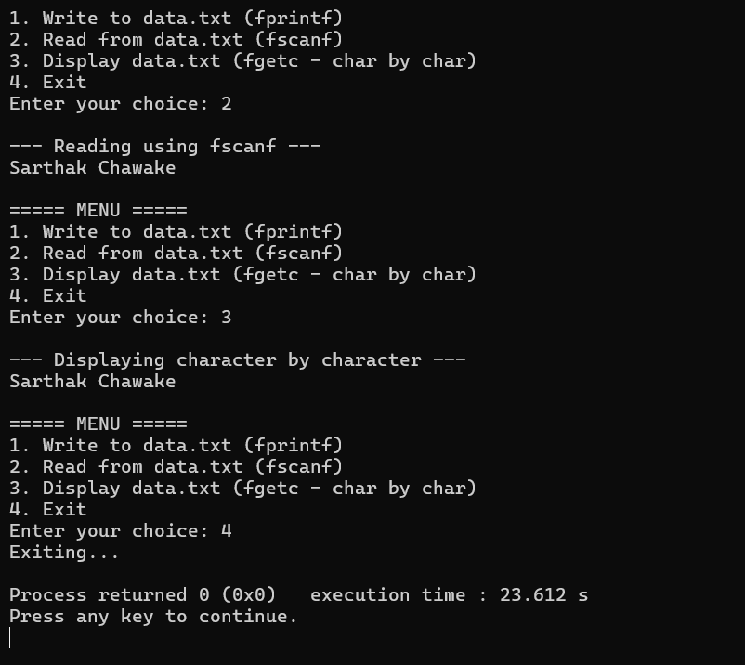
Implementation: -

Conclusion: -

Thus we have fulfilled our objective and performed various file handling operations.

